SAFE EUROPE project webinars impact study

The overall aim of the SAFE EUROPE project was to create a series of webinars to close gaps in the knowledge, skills, and competencies of Therapeutic Radiographers/Radiation Therapists (TR/RTTs). These gaps were identified from the research also performed as part of this research project. The research included the identification of gaps practised across different aspects of Radiotherapy (RT) practice: linear accelerator competencies, digital skills, green skills, and advanced roles. The research also took the perspective of different stakeholders, with emphasis on the patients’ perspectives. Three webinar series and 18 webinars (Table 1) were created in collaboration with the EFRS RT committee.
Table 1 – List of webinar episodes as part of the SAFE EUROPE project
Episode code | Episode title
S1E1 | Use of pharmaceuticals in the management of radiotherapy side-effects (Part 1)
S1E2 | Use of pharmaceuticals in the management of radiotherapy side-effect (Part 2)
S1E3 | Daily, monthly, and annual QA procedures for linear accelerators
S2E1 | Software-related accidents in radiotherapy: what can we learn from them?
S2E2 | Mini-series incident cases: Incident learning in proton therapy in MAASTRO: An incident due to wrong table density.
S2E3 | Proactive risk analysis in practice: Failure Mode and Effects Criticality Analysis (FMECA)
S2E4 | Mini-series incident cases: Who is the patient on the treatment table? Learning from a clinical case
S2E5 | Radiobiology of hypofractionation
S2E6 | Organisation of a brachytherapy unit: technology, safety, and patient-centered care
S2E7 | Proton Therapy: theories and practices from a radiographer’s perspective
S2E8 | Online adaptive MRI guided radiotherapy – changing role of the therapeutic radiographer
S2E9 | Stereotactic RadioSurgery (SRS) and Stereotactic Body Radiation Therapy (SBRT)
S2E10 | An introduction to Surface Guided Radiotherapy: Improving patient positioning, comfort and treatment accuracy.
S2E11 | Clinical Trials: From finding the right question to implementation
S3E1 | Management and leadership in healthcare and radiotherapy
S3E2 | How can healthcare professionals contribute to a sustainable world? Developing TR/RTTs green skills
S3E3 | Digital content creation by TR/RTTs: developing digital skills
S3E4 | Patient advocacy for TR/RTTs

The aim of this impact study was to assess the quality and impact of the SAFE EUROPE webinars. As such, the research questions that this study aims to answer are:
- Were the webinars of good quality?
- What was the impact of the webinars?

Methodology
The self-designed questionnaire aimed to answer the research questions mentioned above. This questionnaire was designed to evaluate the perceived quality of the webinars and their impact (increase in knowledge/skills and change in practice).
Questionnaires are useful to survey a large number of attendees and achieve a broader understanding of the quality and impact of the webinars. Questionnaires are also easy to distribute and analyse since they allow a measure of participants’ perception of the quality and impact of the webinars in a quantifiable way.
Interviews were considered, however, the research questions could be answered through surveys. This may have allowed participants the opportunity to explore further some of their answers, allowing a deeper understanding of the impact of the webinars on the participants’ practice. However, this could also be achieved by having open-ended questions in the survey if the participants wish to explore their answers further. Because the interviews were not anonymous, there was the possibility of courtesy bias - i.e. when answers are positive since the interviewer is a SAFE EUROPE researcher.
Population: SAFE EUROPE webinars attendees
Recruitment and sampling: Survey disseminated through mailing lists (to members/associates who previously agreed to receive information) and social media of the SAFE EUROPE partners and their associates. The aim is to reach as many webinar attendees as possible. This is considered a non-randomised convenient sampling since people who access the SAFE EUROPE partner’s social media will be “conveniently” invited to answer the survey (therefore, this may not include all attendees). However, since the webinars are primarily promoted through social media and mailing lists, the attendees’ population and the population of people invited to answer the survey should closely overlap.
Ethical considerations
- A Participant Information Sheet is provided before the start of the survey (see below)
- Participation is voluntary and opt-in (i.e. invitations will be performed and participants must voluntarily click the link to participate)
- The survey is anonymous. Besides the participants’ roles, no other personal information will be asked.
- None of the questions request sensitive information.
- There is no risk of harm to the participants.
- The results will be published on the SAFE EUROPE website (www.safeeurope.eu) and may also be published in a peer-reviewed journal.
- Participants can withdraw from the study at any time before submission of the survey. Due to anonymity, it is impossible to withdraw the answers after submission.
- After submission of the questionnaire, participants will be able to share their email to be contacted for follow-up questions. The reply to these questions is also completely voluntary. The email submission will not be associated with the questionnaire to ensure anonymity.
- By submitting the survey, it is implied that participants give consent to collect this data.
Data Protection Statement
All data will be protected under the Data Protection Act 2018 (UK) that was updated following the
introduction of the General Data Protection Regulation (GDPR). The researcher abides by the GDPR policy at Ulster University (link: https://www.ulster.ac.uk/__data/assets/pdf_file/0006/286008/ GDPR-Policy-updated-20-08-19.pdf). The information will be treated with strict confidence, and none of the participants will be identified.
All data will be kept safely protected by passwords and using encrypted servers. Electronic data will be saved and adequately backed up in UK servers. Only the named investigators will have access to the data. All data will be used exclusively for this research project and will be kept for 10 years following the end of the project as per Ulster University regulations.

Results
The impact study obtained 167 responses. Thirteen (13) respondents did not attend the SAFE EUROPE webinars and were excluded, achieving 154 valid responses. Out of these, 27.3% are TR/RTTs. However, a variety of professionals attended these webinars, as seen in Table 2. Of these, 63% have roles as educators. Each webinar was attended by between 33% and 59% of the respondents to this impact study.

Table 2 – Distribution of professions of the attendees answering the impact study, including codes used for the quotes
Profession | n | % | Code used for the quotes
Therapeutic Radiographer/Radiation Therapist | 41 | 27.3 | TR/RTT
Radiographer (RT/MI/NM) | 24 | 16.0 | RAD
Medical Physicist | 22 | 14.7 | MP
Diagnostic Radiographer, including Nuclear Medicine | 20 | 13.3 | DR/NM
Academic | 9 | 6.0 | ACA
Student | 7 | 4.7 | STU
Manager | 5 | 3.3 | MNG
Researcher | 5 | 3.3 | RES
Engineer | 3 | 2.0 | ENG
Physician | 3 | 2.0 | MD
Quality Manager | 3 | 2.0 | QM
Radiation Safety Officer/Expert | 3 | 2.0 | RS
Other | 2 | 1.3 | OTH
Regulator | 2 | 1.3 | REG
Nurse | 1 | .7 | NUR
TOTAL | 150* | 100%
*4 respondents did not answer this question

Participants included RT staff from around the world, Europe, Africa, Asia, (North, Central and South) America, and Oceania. The distribution of the attendees’ countries can be seen in Figure 1 and Table 3.
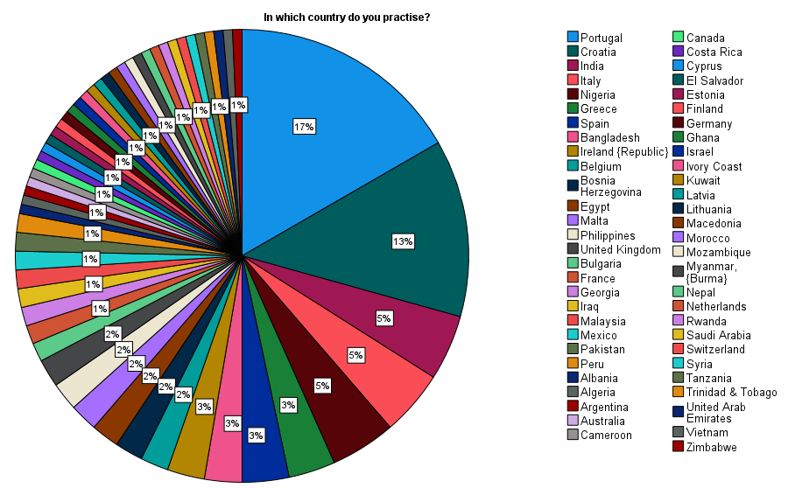

Figure 1 – Country distribution of the attendees answering the impact study

Table 3 - Country of the attendees answering the impact study
“In which country do you practise?”
 |  | Frequency | Percent
 | Portugal | 25 | 16.7
 | Croatia | 19 | 12.7
 | India | 7 | 4.7
 | Italy | 7 | 4.7
 | Nigeria | 7 | 4.7
 | Greece | 5 | 3.3
 | Spain | 5 | 3.3
 | Bangladesh | 4 | 2.7
 | Ireland {Republic} | 4 | 2.7
 | Belgium | 3 | 2.0
 | Bosnia Herzegovina | 3 | 2.0
 | Egypt | 3 | 2.0
 | Malta | 3 | 2.0
 | Philippines | 3 | 2.0
 | United Kingdom | 3 | 2.0
 | Bulgaria | 2 | 1.3
 | France | 2 | 1.3
 | Georgia | 2 | 1.3
 | Iraq | 2 | 1.3
 | Malaysia | 2 | 1.3
 | Mexico | 2 | 1.3
 | Pakistan | 2 | 1.3
 | Peru | 2 | 1.3
 | Albania | 1 | .7
 | Algeria | 1 | .7
 | Argentina | 1 | .7
 | Australia | 1 | .7
 | Cameroon | 1 | .7
 | Canada | 1 | .7
 | Costa Rica | 1 | .7
 | Cyprus | 1 | .7
 | El Salvador | 1 | .7
 | Estonia | 1 | .7
 | Finland | 1 | .7
 | Germany | 1 | .7
 | Ghana | 1 | .7
 | Israel | 1 | .7
 | Ivory Coast | 1 | .7
 | Kuwait | 1 | .7
 | Latvia | 1 | .7
 | Lithuania | 1 | .7
 | Macedonia | 1 | .7
 | Morocco | 1 | .7
 | Mozambique | 1 | .7
 | Myanmar, {Burma} | 1 | .7
 | Nepal | 1 | .7
 | Netherlands | 1 | .7
 | Rwanda | 1 | .7
 | Saudi Arabia | 1 | .7
 | Switzerland | 1 | .7
 | Syria | 1 | .7
 | Tanzania | 1 | .7
 | Trinidad & Tobago | 1 | .7
 | United Arab Emirates | 1 | .7
 | Vietnam | 1 | .7
 | Zimbabwe | 1 | .7
 | Total | 150 | 100.0

Quality
68.8% (n=105) of the participants considered the webinars of excellent quality, and 98.7% (n=152) considered them either good or excellent. No one considered it poor or very poor, as seen in Figure 2.
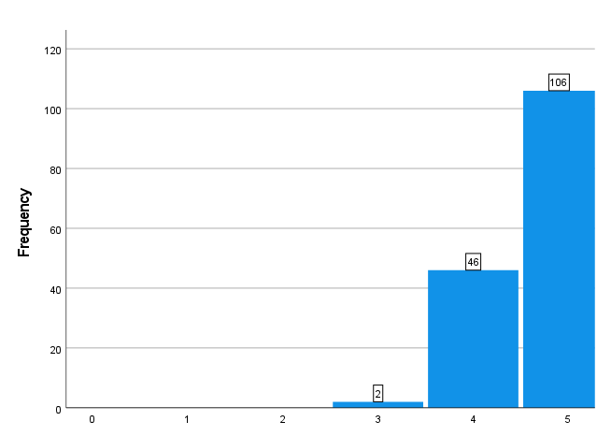
Figure 2 – Rating of the overall quality of the webinars. Rating between 1 (very poor) and 5 (excellent).

In addition to the quantitative evaluation, the answers to the open questions confirmed this opinion that the webinars were of good quality: “The quality of the information taught by the professionals was excellent. I learned a lot of new concepts and topics to implement in my RT department” (P27 – CR – TR/RTT). They also confirmed that the subjects were “Very well explained” (P69 – CA – MNG) and that “they were presented nicely” (P92 – AE - STU). The code used for the participants includes the participant number, the country of practice (ISO 3166 two-letter country codes – www.iso.org/iso-3166-country-codes.html) and the profession code from Table 1.
Another surrogate for the quality of the webinars is that most participants (n=133, 86%) recommended the webinars to their colleagues (Figure 3). Additionally, most respondents (n=129, 84%) agreed or strongly agreed that these webinars are also suitable for students (Figure 4).
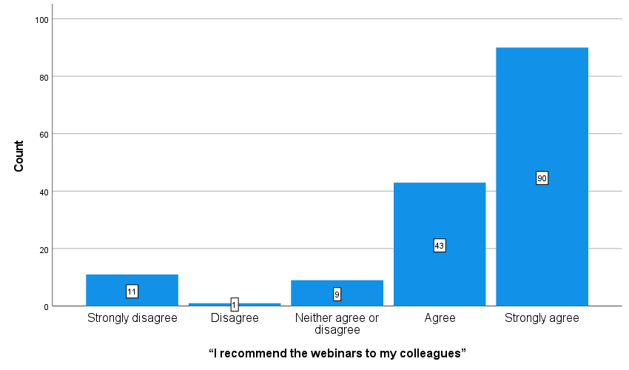
Figure 3 - level of agreement with the statements related to recommending the webinars to colleagues

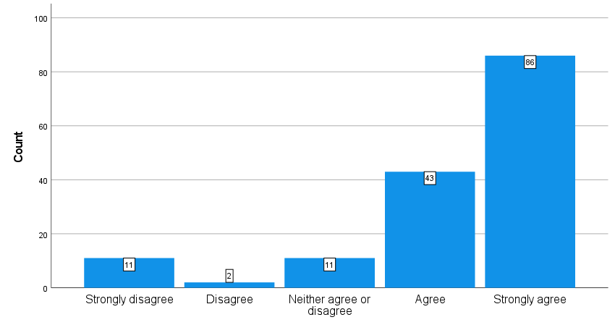
Figure 4 - level of agreement with the statements related to recommending the webinars to students

Usefulness and impact
Most respondents indicated that they either “agree” or “strongly agree” with the statements that the webinars increased their knowledge (n=131, 85%) or their skills (n=113, 73%), respectively. With a minority disagreeing or strongly disagreeing with these statements (n=13, 8% and n=15, 10%, respectively). This can be confirmed in Figures 5 and 6.

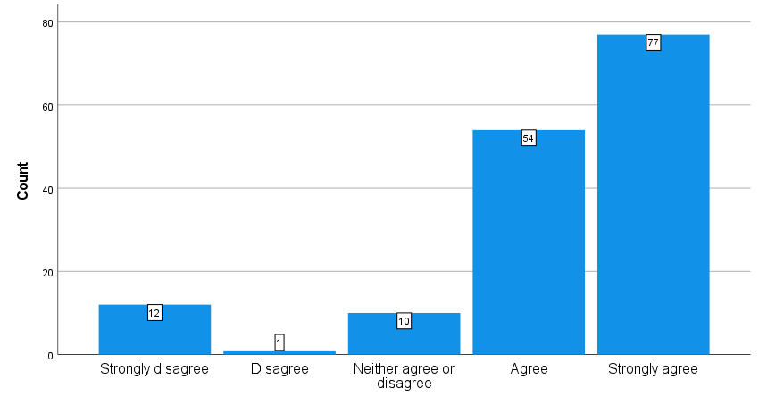
Figure 5 – level of agreement with the statements that the webinars increased the participants’ knowledge

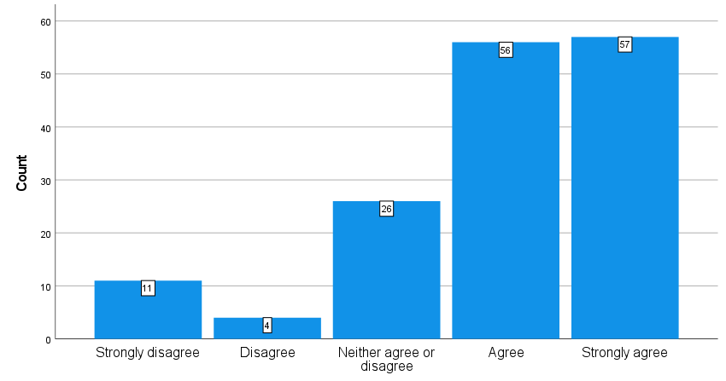
Figure 6 – level of agreement with the statements that the webinars increased the participants’ skills

From the open questions regarding why they found some of the episodes useful, one of the themes was that the webinars were useful as an update and as a review of topics learned before: “they were an update and remainder of those topics we deal with at the clinic” (P11 – MX – MP); “useful to refresh concepts” (P38 – ES – DR/MN); “Webinars are important to get knowledge of new technologies and to revive the memory of those already learned” (P109 – PT – TR/RTT); “paradigm of RT has changed since I first trained, it was helpful to draw these concepts together with a radiobiological focus” (P25 – AU – ACA); “They were useful to me due to the fact that I mainly develop in this field and am interested in the novelties in the planning and treatment of cancer patients” (P87 – BG – MP).
Another theme was that the webinars shared experiences from other departments, which the participants would not have access to: “Sharing the experience and practices/organization from professionals in other departments around the world” (P57 – BG – MP); “Learning from the experiences and way of working of others allows us to improve certain aspects of our professional practice.” (P61 – PT – TR/RTT).
Respondents generally agreed or strongly agreed that the webinars motivated them to change their practice (n=122, 79%) and plan to use the knowledge in their practice (n=125, 81%). Additionally, many respondents had already applied them into practice at the time of this study (n=100, 65%), and many already saw change in their departments (n=104, 68%). There is a decrease in the level of agreement between the intention to apply knowledge to change practice (mean score=4.04) and the practice already changed (mean score=3.69), and this difference is significant (X²(1)=38.754 p<0.001). The level of agreement with the statements related to application into practice can be seen in Figures 7 to 10.
`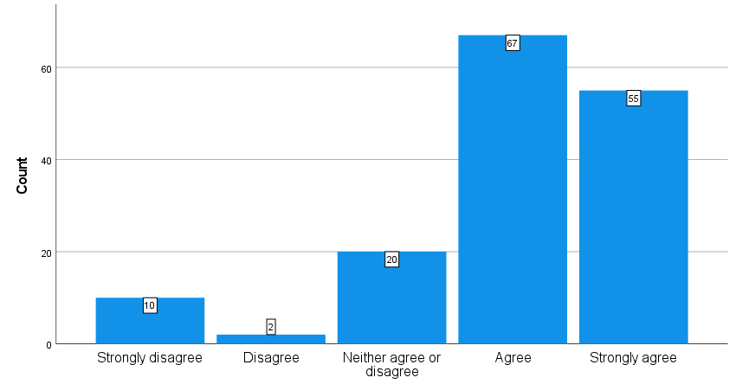
Figure 7 - level of agreement with the statement “the webinars motivated me to change something in my professional practice”.

`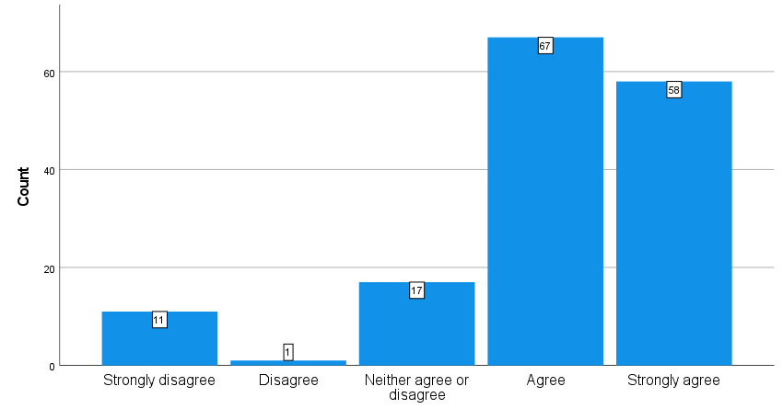
Figure 8 - level of agreement with the statement “I plan to use the knowledge/skills gained in my practice”.

`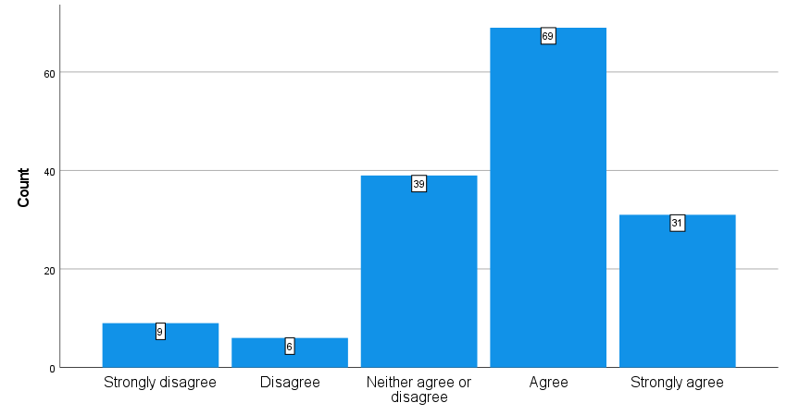
Figure 9 - level of agreement with the statement “I already used the knowledge/skills gained in my practice”.

`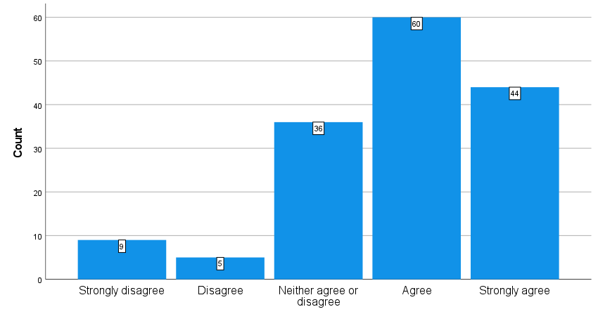
Figure 10 - level of agreement with the statement “the webinars promoted a positive change in practice in my workplace”.

Importantly, some respondents indicated that they plan to apply the new knowledge to their practice: “I can apply explained concepts in my daily work” (P38 – ES – DR/NM); “I learn new thing I use in my work in radiotherapy” (P78 – DZ – MP)
Some participants who have teaching roles also identified that they plan to apply the knowledge in their teaching. “to share and teach my colleagues and as lectures” (P31 – MM – MP); “These topics are relevant to my current lecturing and research activities” (P14 – IE – ACA).
Most respondents agreed or strongly agreed that lecturers can use the webinars in their teaching (n=123, 80%) (Figure 11) or as on-the-job training and CPD (n=123, 80%) (Figure 12). In reality, among those who stated that they perform roles as educators academically or clinically (n=93), 50 respondents (54%) agreed or strongly agreed that they used the webinars in their teaching (Figure 13).
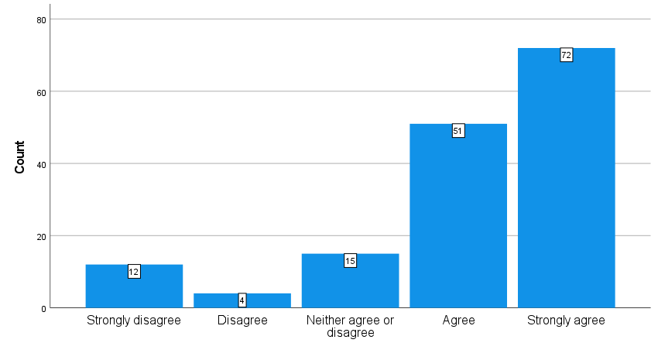
Figure 11 - level of agreement with the statement “these webinars can be used by lecturers in their teaching”.

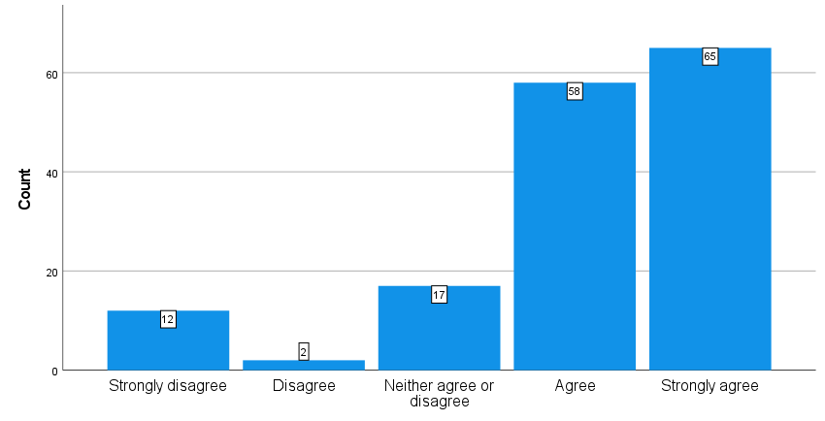
Figure 12 - level of agreement with the statement “these webinars can be used for training of healthcare professionals after graduation (e.g. on-the-job training and CPD”.

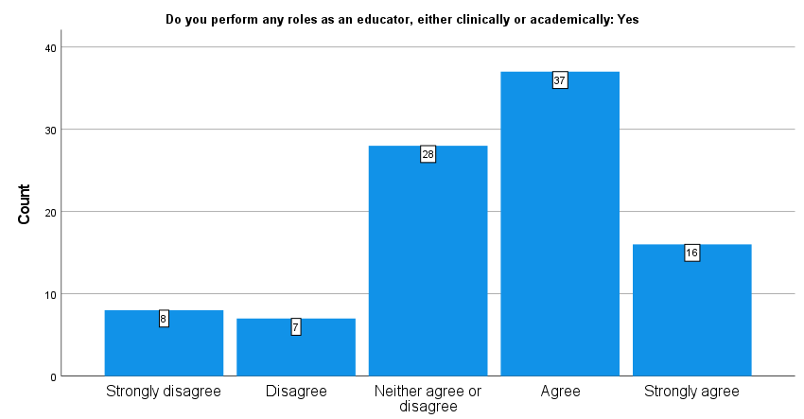
Figure 13 – Level of agreement with the statement “I used these webinars in my teaching”

Participants who are students or newly graduates referred that these webinars helped to increase their knowledge (students/new graduates): “New concepts at my level as a student” (P46 – IE - STU) or “Helpful for fresh medical physicist” (P30 – NP – STU).
Some participants referred to the usefulness of specific webinars and their importance. For example, one participant highlighted the usefulness of “learning from previous incidents” (P39 – NG – DR/NM) when discussing the mini-series episodes about incidents in RT. A participant stated that the webinar about circular economy ”has exposed me on how to use eco-friendly materials” (P44 – NG – TR/RTT), however, other participants found this webinar less useful “The webinar, in general, was not much related to green skills in the RT profession from my perspective. I thought it was going to have a different orientation to perform green skills from our role in practice.” (P27 – CR – TR/RTT). Another participant found the patient-care-related webinars (S2E4 and S3E4) beneficial even though this participant is not a clinician “That how we should talk much care about patients, who they are and how we treat them” (P67 – HR – ENG).
Some webinars were considered less useful because they covered topics not being practised by the attendees. Relating to S1E1 and S1E2, a participant stated that “While the content of these webinars was excellent, and it was interesting to gain an insight into the role of the RT radiographer in managing RT side effects, the topic does not directly relate to my current teaching role” (P14 – IE – ACA). While another participant mentioned that “I don’t deal with protons” (P55 – PH – MP) when stating that the S2E7 webinar was not valuable.

Discussion
Although the webinars had the European TR/RTT market as the target, participants from all backgrounds were welcome to attend. This is reflected in the distribution of professions and countries replying to this impact study. This attendance shows an overlap of the body of knowledge between the various professions working in RT and emphasises the solid multidisciplinary teamwork required in RT departments. It also shows that not only do European professionals need additional and continuous training, but this need is felt worldwide.
The data showed that webinars were of good quality. This is directly observed in the answers to the open-ended questions, where it is stated that the presentations and presenters were good, but also in close-ended questions about the quality of the webinars. Additionally, most respondents (86% and 84%) recommend these webinars to colleagues and students.
The webinars increased the knowledge and skills of most participants (85% and 73%, respectively), and these participants intend to apply this new knowledge into practice (81%). Some of these participants had already done so by the time of this impact study (65%). Therefore, the main aim of these webinars (to improve radiotherapy practice) was achieved.
This increase in knowledge comes from new topics covered during the webinars, such as new techniques or concepts that haven’t been covered in their initial educational programmes. Therefore, webinars seem to be an excellent way to provide CPD to these professionals.
In particular, some participants mentioned in the open-ended questions the importance of sharing experiences from different departments. This shows that knowledge and skills tend to be developed locally and European/worldwide webinars may be an efficient way to disseminate knowledge beyond local departments and country borders.
Some participants stated that the webinars were useful for revising topics they have learned before (but have forgotten). This knowledge loss phenomenon was studied before, and revising topics covered in the initial education is essential to keep the knowledge. Once again, webinars are an effective method to achieve this goal.
Another aim achieved was to have these webinars used as learning activities. Most participants (80%) agreed that these webinars are valuable teaching tools. The quantitative data was complemented by usefulness statements given by students in the open-ended questions. The use of webinars was already taken onboard by 54% of the participants who have teaching roles, showing the significant impact achieved by this project.
Some webinars were considered less useful because the topics were not relevant to the participant. This was the only explanation given by the participants who indicated that some webinars were less useful.

Conclusion
The webinars achieved the aims set at the beginning of the SAFE EUROPE project: to improve practice (through increasing knowledge and skills) and to be used as teaching tools. As such, the impact of these webinars, which are the end-product of the SAFE EUROPE project, is extensive not only for TR/RTTs in Europe (target audience) but for a range of professionals worldwide.

